# Google Map Integration

As before, this was the integral part of the app with relation to the GPS usage, to be able to view different events with relation to their current location.

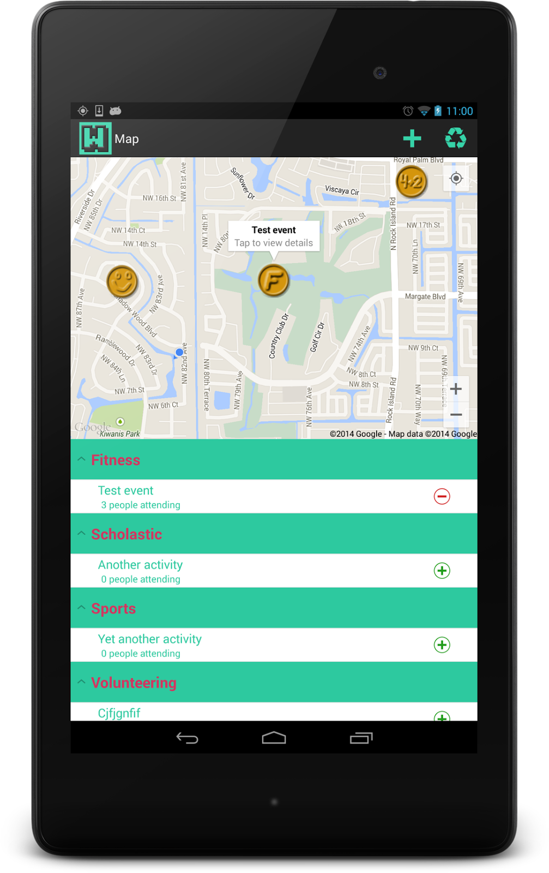

Essentially, we created map markers for each event within the accordion list. Clicking an item in the Accordion list would zoom the map and center on the event tapped on, also bringing up an infowindow object on the event in particular. Clicking this allows you to launch a modal window to either view details, or edit an event if you are the owner. Alternatively, we integrated the OnLongClickListener interface on the MapScreen class, allowing us to populate a new instance of the EventAddEdit with the address fields hidden, as they are now obsolete - we know where the event is, you long tapped to launch the modal.